2023
Oil, Gas, Mining, and Mineral Resources Practice Specialty
American Society of Safety Professionals
4/9/2023
Mentoring Handbook

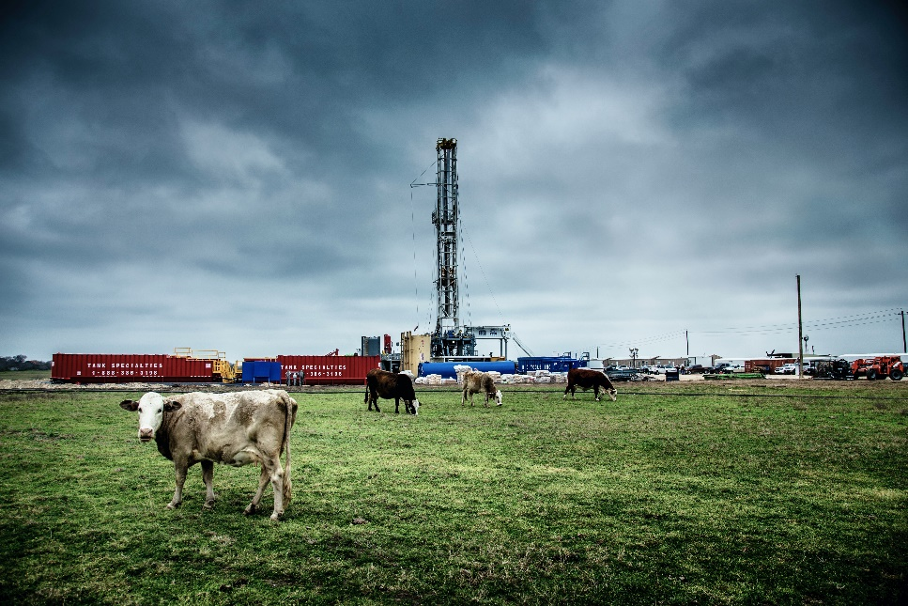
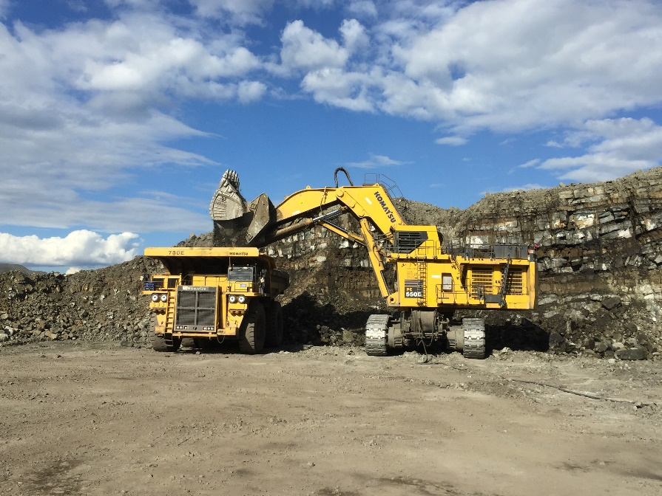

INTRODUCTION
Dear mentors and mentees,
Welcome to the Oil, Gas, Mining, and Mineral Resources Practice Specialty Mentoring Program. These are exciting times as our respective industries continue to evolve. This mentoring program will pair a mentor with a mentee to address potential challenges and trends taking place within someone’s academic or occupational career. These challenges could be related to seeking employment, career advancement, regulatory compliance, or beginning in the profession.
The Oil, Gas, Mining, and Mineral Resources Practice Specialty Mentoring Program will be monitored and managed by the mentor committee consisting of a minimum of three members. Due to potential growth more committee members may be needed to manage the program. Mentor applications will be reviewed and approved by the mentor committee based on knowledge, skills, attitude, industry, experience, and availability. Matches will be made biannually, in August and January, for a duration of four-months. Mentors and mentees may opt to continue their relationship past the mentor program. Students will be limited to a four-month mentorship during their academic year.
An overview of the mentoring process will be provided within this handbook. We recommend you review the material in the program to establish a path forward. The handbook can be revisited throughout the mentoring relationship. The handbook can be used a tool to navigate the mentoring relationship in a structured and effective manner.

OIL, GAS, MINING, AND MINERAL RESOURCES PRACTICE SPECIALTY COMMITMENT
The American Society of the Safety Professionals Oil, Gas, Mining, and Mineral Resources Practice Specialty is committed to diversity, equity, and inclusion. The committee strives to provide a safe and productive environment that fosters open dialogue, free of harassment, discrimination, and hostile conduct. An environment will be fostered that encourages open dialogue.

RESPONSIBILITIES AND EXPECTATIONS
Mentors and mentees must be members of the Oil, Gas, Mining, and Mineral Resources Practice Specialty in good standing.
Mentors must have a minimum of 5-years’ experience in the industry they will be providing mentor services.
Mentees must be seeking mentorship as a student, early career hire, career change within industry i.e., oil, gas, mining, or minerals, or an industry career change e.g., utilities to oil industry. The intent is to provide career guidance to the mentee to improve safety performance and compliance within the oil, gas, mineral, or mining industry.

CODE OF CONDUCT
- Mentors and mentees must adhere to the ASSP Code of Professional Conduct. https://www.assp.org/about/society-bylaws-and-guidelines/code-of-conduct
- Both parties must avoid discussing prices of goods and services.
- Company specific merger/divestment plans, production information, future developments, inventories, costs, or purchasing plans must be avoided.
- Confidential or propriety information must not be discussed or shared.
- Company compliance costs must not be shared or discussed.
- Specific products and services should be discussed in generalities so as not to promote a distinct product or service.
- Do not serve as a mental health professional.
- Do not offer money or employment.
- No defamatory language remarks about individuals or companies.
- In-person meetings should take place in an appropriate environment.
- Refrain from “friending” your mentor/mentee on social media until the mentorship has been completed.

THE MENTEE EXPECTATIONS
To create a safe, encouraging environment, mentees are expected to display good behaviors, such as:
- Being accountable. You should care more about your development than anyone else. Be timely to scheduled meetings as time is linear and cannot be replaced. Do not be afraid to initiate conversations.
- Invest time and energy. Devote time and energy to establish benchmarks and identify and achieve your goals.
- Display openness. Actively listen, ask questions, and consider the mentors communications.
- Exhibit a professional demeanor. Mentees should be in an answer-seeking role to maintain an appropriate relationship.
- Accept constructive feedback. You must maintain an open mind being willing to take advise.
- Take the time to listen, learn, and interact. You get out of the program what you put into it.
- Communicate with your mentor. Let your mentor know if you need to terminate the mentorship program.

MENTORSHIP FIRST MEETING
The Mentor committee will review the mentor and mentee applications. Pairings will take place to ensure the most appropriate mentor is matched with the mentee. The mentor should contact the mentee as soon as possible to begin building a firm foundation to guide future meetings.
The ‘Conversation Starters’ is a guide for developing a rapport between the mentor and mentee. Each group of mentor participants will experience the process of forming, storming, norming, performing, and adjourning. This foundational step supports the forming stage of development.
The ‘Initial Meeting’ guide is provided to aid in the first meeting. Developing a dialogue/rapport will take time as some people are not as extroverted as others. There is also an element of trust that must be achieved in the initial forming and storming stages of establishing the relationship.

MENTORSHIP MATCHING
Mentors and mentees will be matched based on alma mater and industry specialty, if possible.

FOUNDATION FOR A SUCCESSFUL MENTORSHIP
Confidentiality must be maintained throughout the mentorship program while maintaining transparency, trust, and loyalty. Information exchanges should be limited to the mentorship program and should not extend beyond the mentor / mentee relationship.

POST MENTORSHIP FOLLOW-UP
A post-mentorship interview/follow-up will be conducted six months after the mentorship ends. A post-mentorship survey will be provided to the mentee and mentor to continuously improve the process.

RESOURCES
The American Society of Safety Professionals offers a variety of career development opportunities. Guidance is available on becoming a safety professional. Safety management, leadership in safety management, and global safety management certificates are available as self-improvement opportunities. Associate safety professional, certified safety professional, and safety management specialist certification preparation courses are available. Lead forward: ASSP volunteer leadership development is available as an online, instructor-led course, without associated fees. Fee based self-paced online courses, live virtual classroom courses, on-demand learning courses and training and education is available for safety teams. Also, live webinar sessions are conducted.

Conversation Starters
A few Key Points:
Ask open-ended, thoughtful questions. | Do what you say you are going to do.
Be careful about establishing defined timelines, consider obligations regarding your primary job and personal life. | The SMART method is encouraged when establishing goals.  Specific – Measurable – Achievable – Realistic - Timely
Be open and honest | He humble
Avoid divisive subjects (politics, religion, social issues, etc.)

Conversation Starters
Introduce yourself and ask your mentee about themselves.
Talk about your hobbies, favorite movies, books, music, family, community where you live, etc.
Talk about your education (favorite classes, teachers, school).
Talk about your first HSE job.
- How did you get it?
- Challenges?
- What did you learn?
Who/what inspired you to become a leader?
Why did you decide to become a mentor?
If someone was writing the story of your career, what would you want it to be?

General Topics to be Covered during the Mentoring Program
What was the career path that led you to your current position?
Discuss certifications and education attained.
Discuss certifications and education the mentee wants to attain.
What do you do for your own growth and development?
What lessons have you learned from your successes and failures?
What challenges have you faced in your career?
What was the career path that led you to your current position?
What life experiences have influenced you the most?
Beneficial skills to work on (varies by person)

Initial Meeting
Meet once per month for four-months.
Meet: ☐ by phone ☐ by Zoom call ☐ by Microsoft Teams call ☐ Other: _____________
Background:
- Tell me about your time in the oil, gas, mining, or minerals industry.
- Tell me about how you like to spend your free time.
- What do think the benefits are of having a mentor?
- What motivates you?
Profession or industry:
- Tell me about how you found yourself in that line of work.
- What more do you want to get out of your profession or industry?
- Is there an opportunity for upward mobility?
- Is it possible to advance your education while remaining employed?
- How has your experience prepared you or not prepared you for your current career?
- How many hours per week do you spend working as a safety professional?
- What are your thoughts about the social influence on your current profession or industry?
Lifestyles:
- How do you manage a work / life balance?
- What do you want to achieve for networking?
- Do you expect to grow your network through mentorship? If so, how?
- Do you have adequate time to dedicate to being mentored?
Mentorship:
- Are you new to the mentoring process?
- What are you looking to get out of this mentorship that is different from your experience?
- What are three or four goals you would like to achieve during the mentorship?
- How often would you like to communicate?

Mentor – Mentee Meeting Notes
Mentee’s Name:
Mentor’s Name:
Date:
Meeting Location:
Duration of Meeting:
Notes about conversation:

Short Term Goals (1-2 years) / Long Term Goals (2-5 years):
Short term -
Long term -
Progress in Goals, if applicable:

Areas of Strength:

Areas of Growth:

Ways Mentor Can Assist:

Action Steps:

SMART Goals Worksheet

Today’s Date: _______________ Target Date: _______________ Start Date: _______________
Date Achieved: _______________
Goal: ________________________________________________________________________________

Verify that your goal is SMART
Specific: What exactly will you accomplish?

Measurable: How will you know when you have reached this goal?

Attainable/Achievable: Is achieving this goal realistic with effort and commitment? Do you have the resources to achieve the goal? If not, how will you get them? What are the exact steps you should take to accomplish this goal?

Relevant/Realistic: Why is the goal significant to your life?

Timely: When will you achieve this goal?

Mentorship Agreement
The purpose of the mentorship agreement is for both transparency and ownership between the mentor and mentee. To be partners in a mentorship program, both mentors and mentees have the availability and responsibility to set the schedule, frequency, and type of mentorship.
Mentees Name:
Mentee Goals:
1.
2.
3.
4.
Mentors Name:
Mentor Goals:
1.
2.
3.
4.
Mentorship expectations:
_____________________________________________________________________________________
Meetings: ☐ In-person ☐ Email ☐ Phone ☐ Virtual
Frequency: Monthly
Duration: ☐Half hour ☐Hour
Message received: ☐Returned within 24 hours ☐Returned within three business days
Need to cancel meeting – notified by: ☐ Text ☐ Call/Voicemail ☐ Email
Early Dismissal or Termination Process
☐ Failure to uphold expectations
☐ Mismatch between mentor and mentee
☐ Request for reassignment
☐ Mentor or mentee chooses to withdraw from the program
☐ Other personal factors

